Milestone report
MILESTONE: Engine concept Proof
TEAM NAME: Noflex
GAME NAME: Q
NAME: Minjae Kyung
JOBS: Product Manager
DEGREE PROGRAM: RTIS
GAME DESCRIPTION: Our game is a side view platformer rogue-like game. Player is an eminent scientist who participated in the space project.
LINKS: https://github.com/Rudy-Castan-DigiPen-Teaching/game-project-noflex

Work Done :

Main engine(~20 hour)
  - In the engine core, we are using singleton and component design like CS230. but in game, we are using Entity Component System design.
  - Entity manager can Add & Delete Entity on container and get entities by entity type
  - Component Manager can Add & Delete component by Entity ID and bring all components by type also can get component types
  - System Manager can Add system and automatically Update, Load, Unload systems
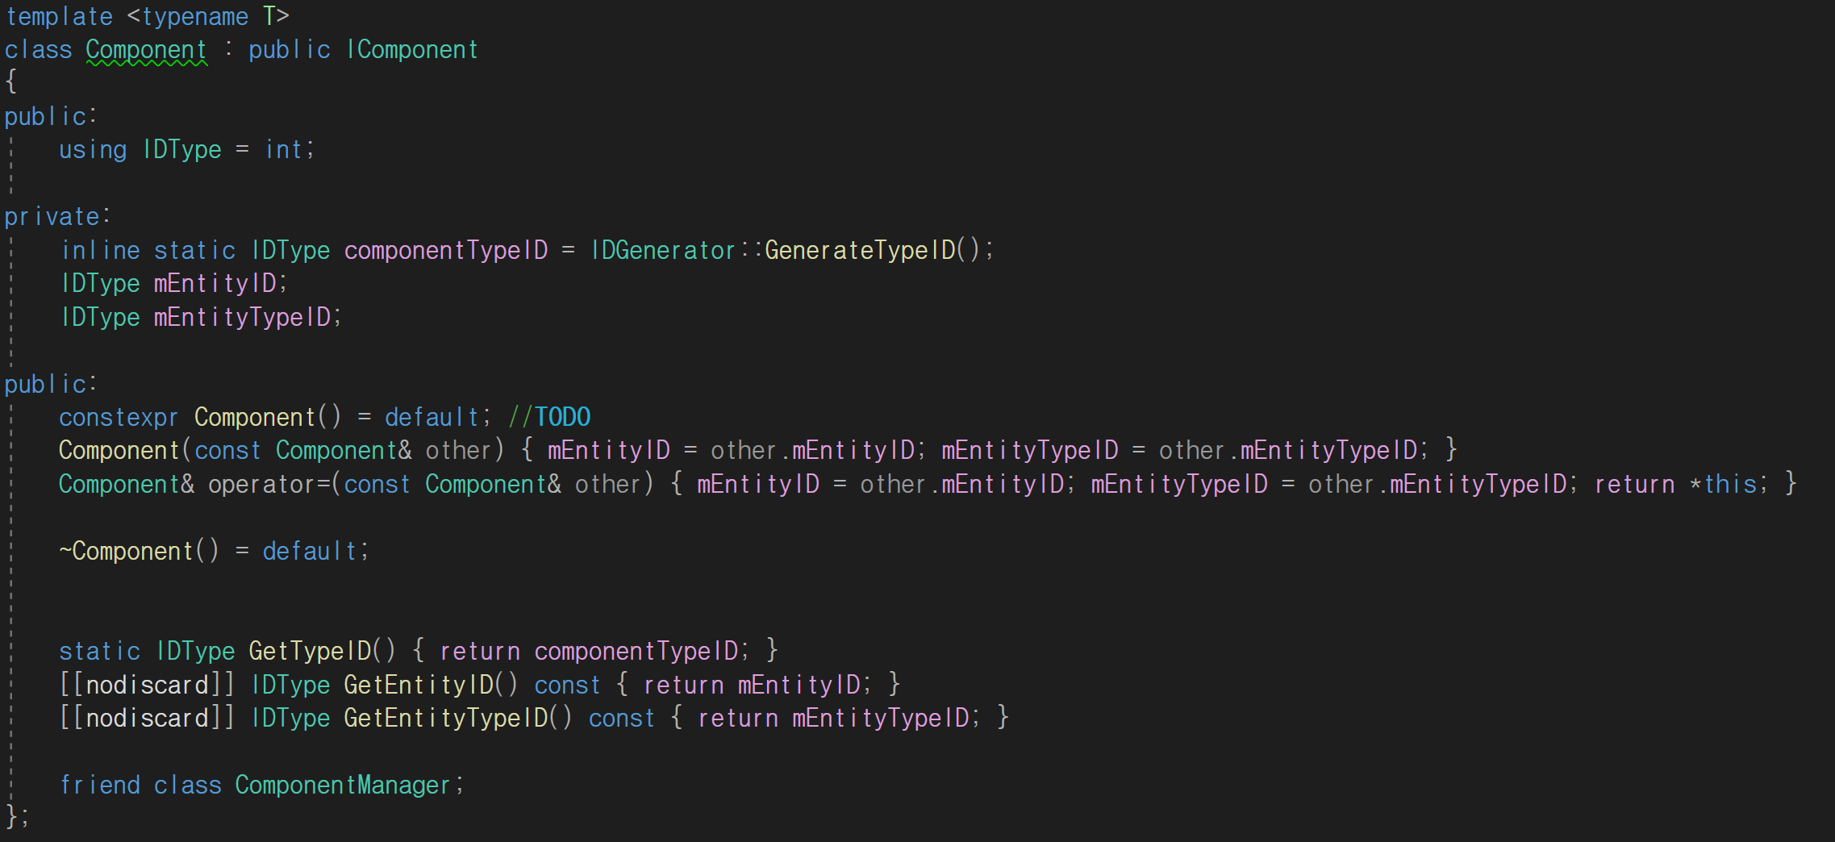
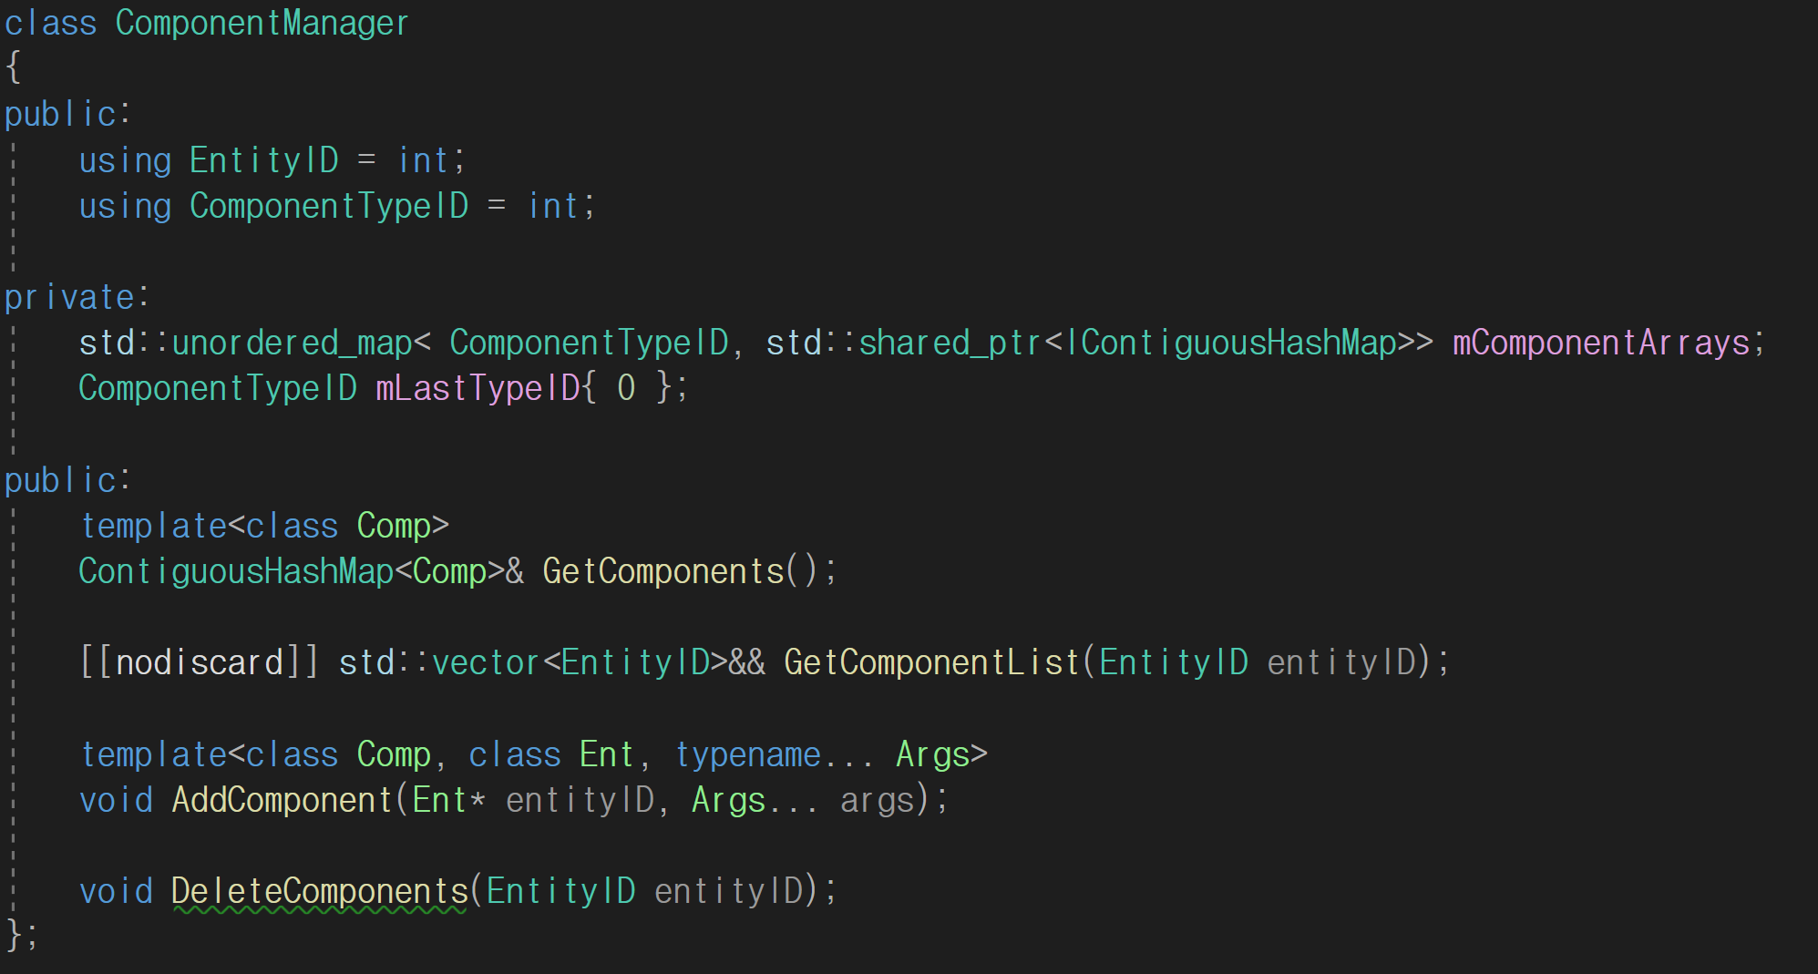

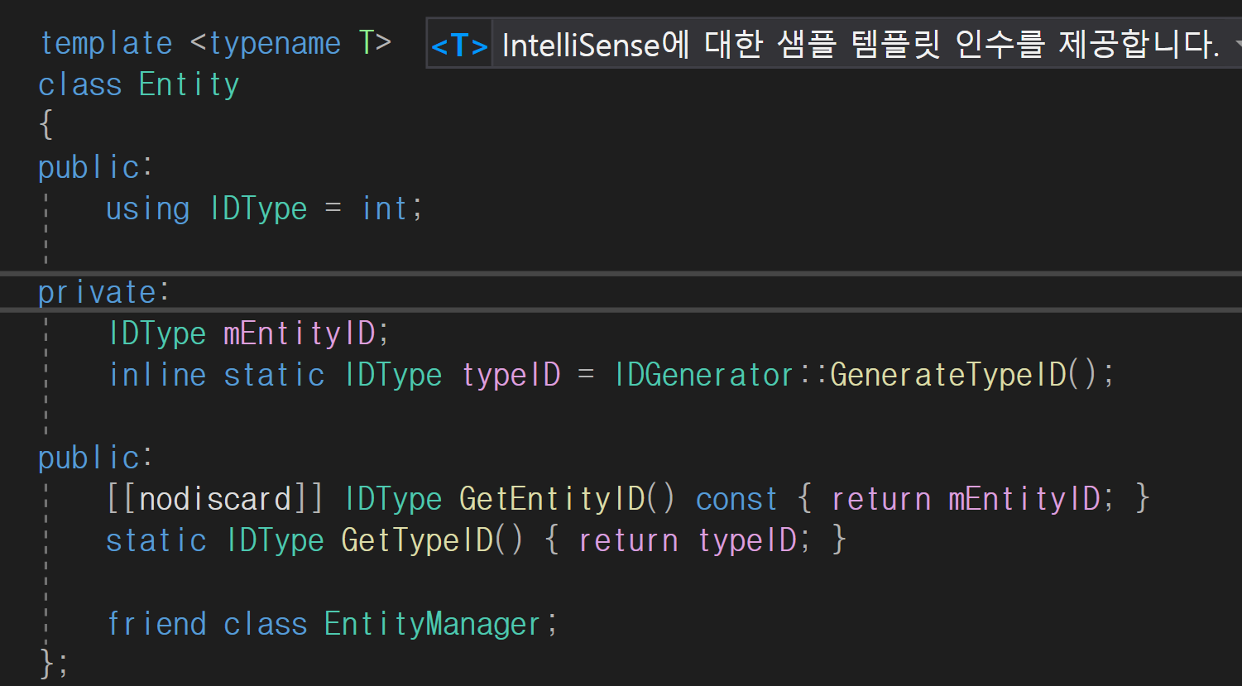
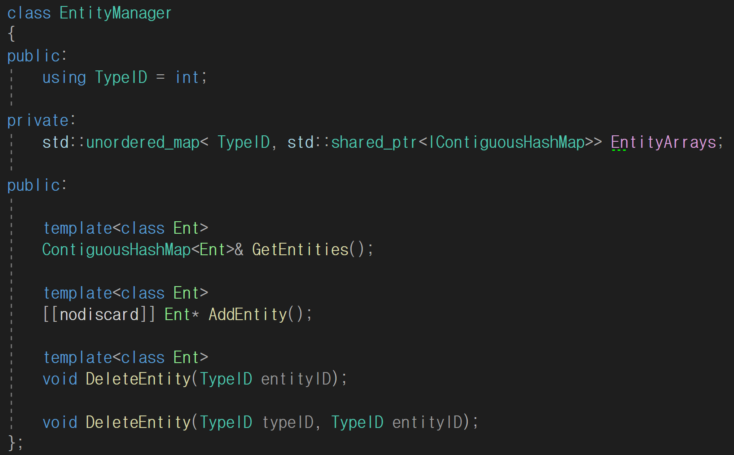
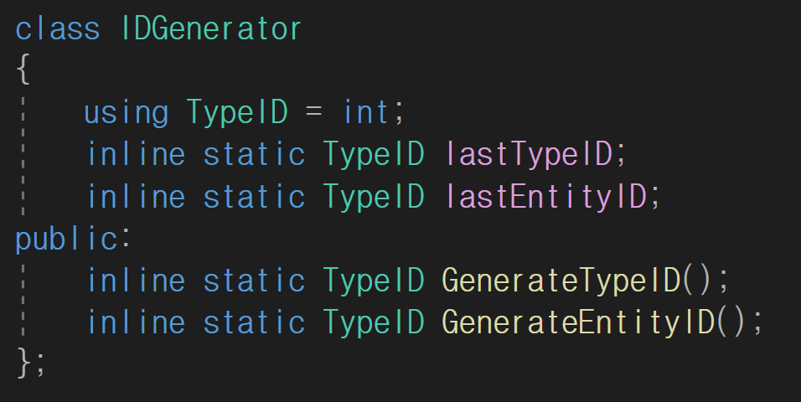
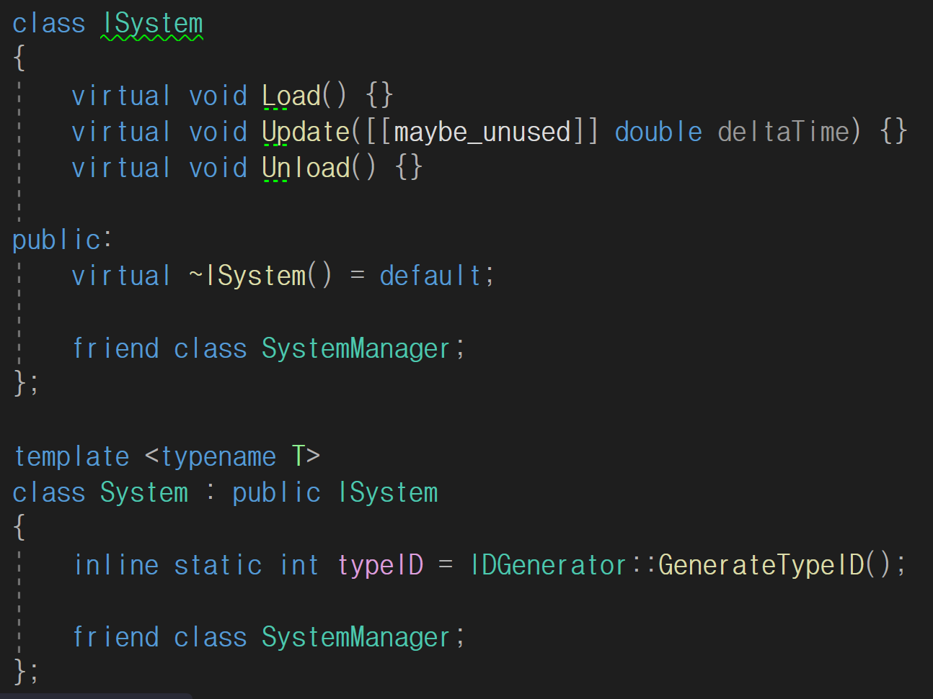
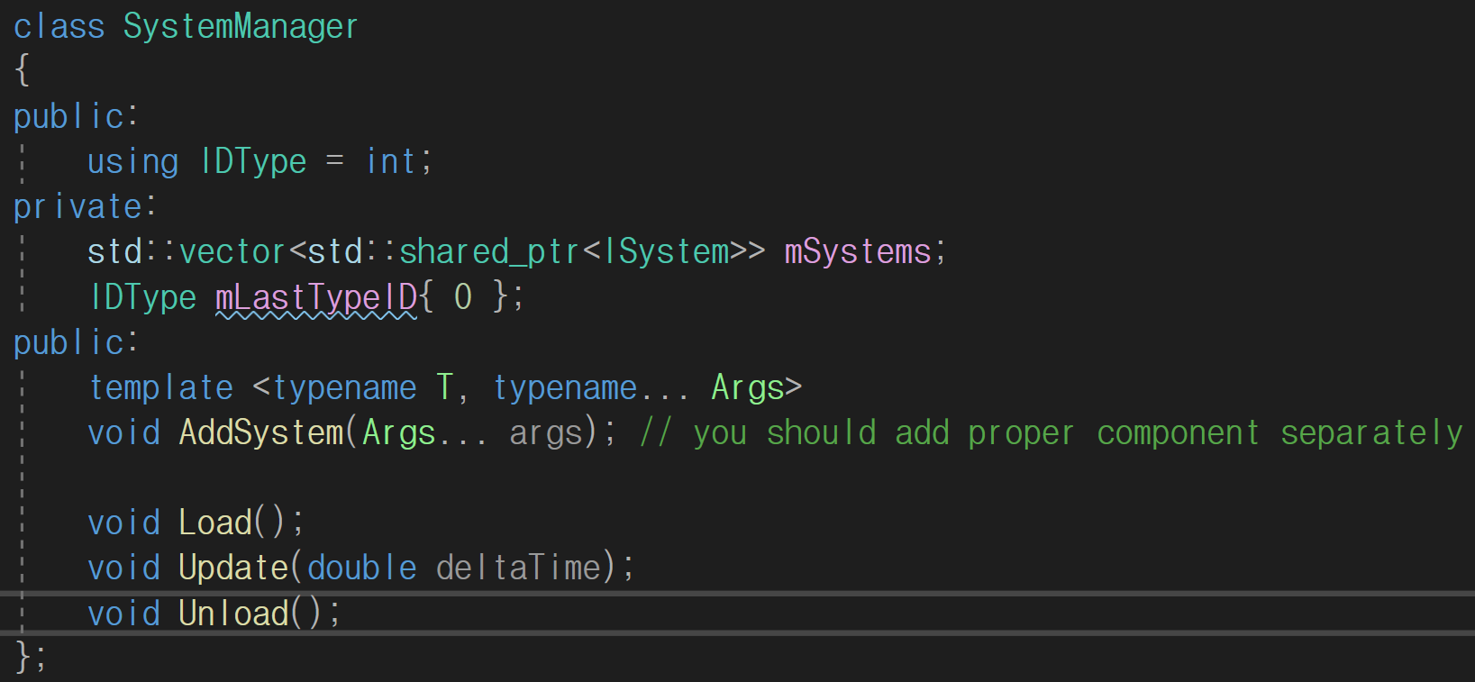

Custom container(~20hour)
  - To implement the ECS system, we need to make our own container.
  - It requires contiguous memory and can be searched by hash.
  - So I mixed a unordered_map and c style array. In map, It stores pointers to real objects and in arrays, it stores objects. so we can expect some improvement on performance while looping all objects.
  - Also it supports contiguous iterators so it can call range-based for loop and std::algorithms. but algorithms are not recommended because hashed pointers can be interrupted.
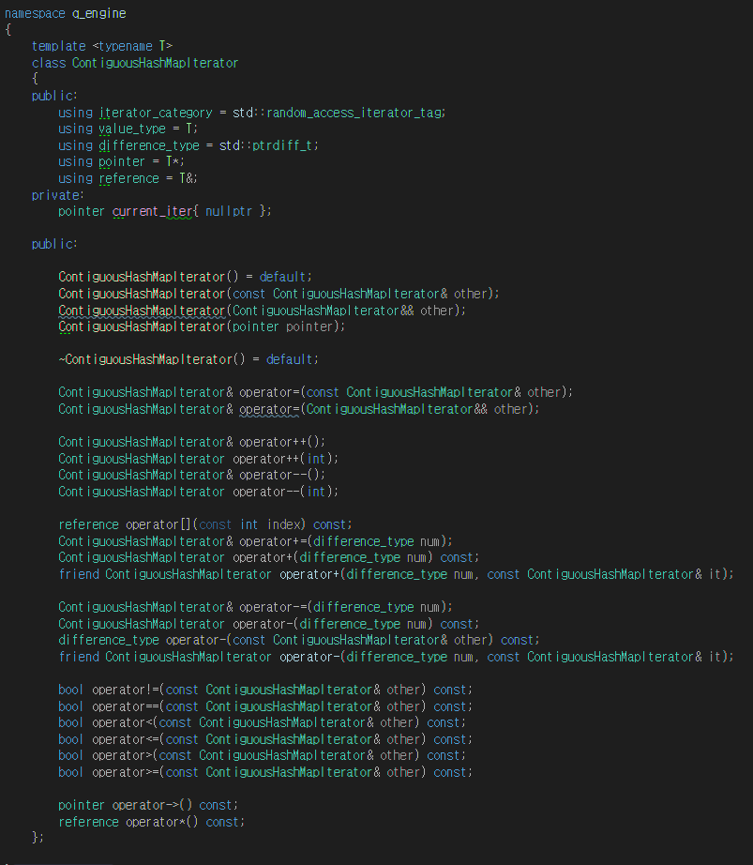
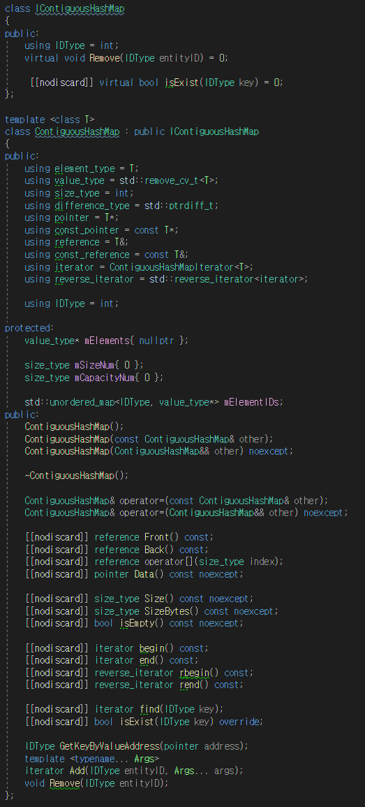

Bezier interpolation(~4hour)
  - It can be used in various ways in animation, It supports both time interpolation and space interpolation so you can make some cool motion graphics combined with graphic drawing.
  - actually I converted it from a previous project to our engine.
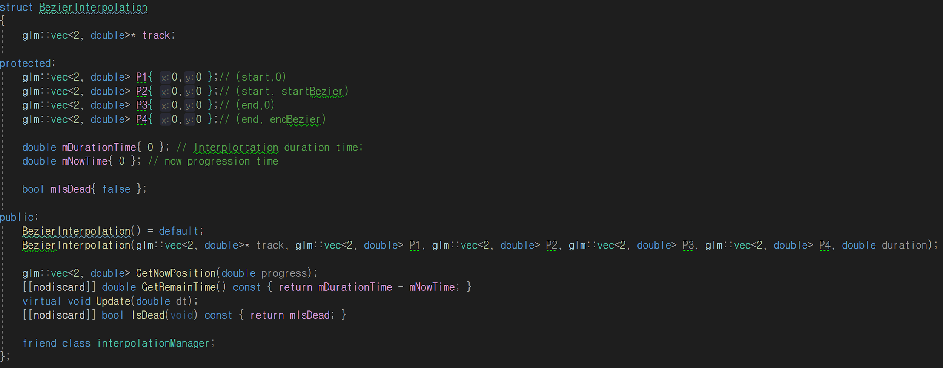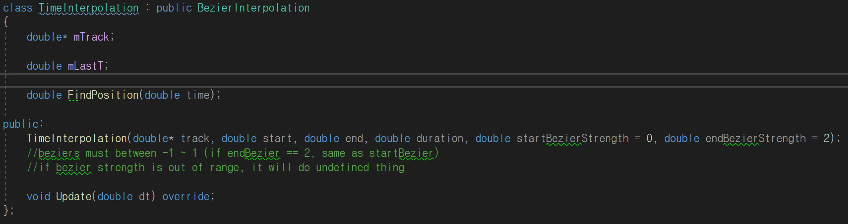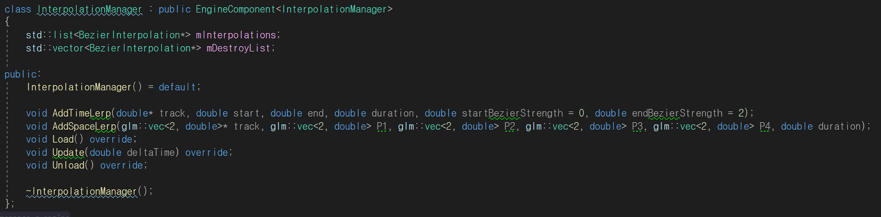

Note
ECS design is quite different from what we’re done so It spends quite of time to understand it

